Platform Team Canvas Analysis for Wagyu AE.
The analysis focuses on the absolute essential competencies needed to build the mobile app platform core while maintaining existing sales, structured into the three required areas.
The competencies are mapped below, with the highest-priority items positioned at the core of each circle.
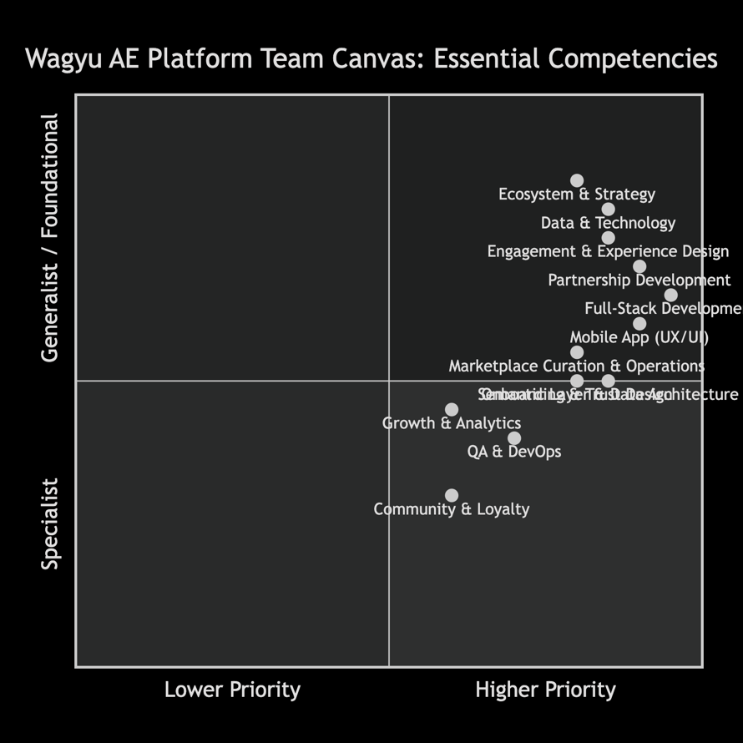

Detailed Breakdown & Rationale
1. Engagement & Experience Design
This area is critical for transitioning your successful B2B model to a trusted B2C/P2P mobile experience.
- Mobile App UX/UI Design & Prototyping (Core): Creating an intuitive, luxury-feeling interface for peer consumers to browse, verify (halal/Omi provenance), and transact. This is the new primary touchpoint.
- User Onboarding & Trust Design (High): Designing flows that seamlessly onboard high-net-worth individuals, establish credibility through your exclusive brand story, and integrate trust signals (e.g., displaying certification data from your semantic layer).
- Community Engagement & Loyalty Strategy (Medium): Planning features for engagement beyond transactions (e.g., exclusive content, chef tutorials, member events) to drive retention. This can be initially led by the CEO/CTO.
2. Data & Technology
This forms the operational backbone of the new platform and integrates with your existing Zoho stack.
- Full-Stack Development (Mobile & API) (Core): The most critical hire. A developer proficient in your chosen stack (Blitzy, etc.) to build the consumer-facing mobile app and the backend APIs that connect it to your inventory, CRM (Zoho), and future semantic layer.
- Semantic Layer & Data Architecture (High): Competency to implement and manage the Neo4j (graph database) and BigQuery integration. This person will structure the complex relationships between products, provenance, certifications, and users—unlocking powerful features like traceability storytelling and personalized recommendations.
- QA, Testing & DevOps (Medium): Ensuring robustness. This role can leverage Meticulous.ai for automated testing and manage deployment pipelines. Initially, this could be a responsibility shared between the Full-Stack Developer and the CTO.
3. Ecosystem & Strategy
This ensures the platform creates value for all sides and scales effectively.
- Partnership & Business Development (Core): While the CEO leads, this competency is vital for formalizing partnerships with logistics, payment processors, and potentially other luxury brands for cross-promotion, ensuring the platform's ecosystem functions smoothly.
- Marketplace Curation & Operations (High): Managing the platform's inventory, pricing, and user-generated content (e.g., reviews, chef profiles). This role ensures quality and consistency, which is paramount for a luxury brand. The CTO can oversee this initially with tools.
- Growth Marketing & Data Analytics (Medium): Using data from the platform and BigQuery to understand user behavior, optimize acquisition, and inform feature development. This can be an initial function of the CEO/CTO, potentially augmented by freelance experts.
Platform Mechanics & Tool Integration
Your chosen tools directly support this lean team structure:
- Blitzy & Qodo: Accelerate development and reduce the initial burden on the Full-Stack Developer.
- Meticulous.ai: Reduces the manual testing load, supplementing the QA/DevOps function.
- Neo4j & BigQuery: The Semantic Layer & Data Architecture role will maximize the value of these tools to build your key USP: verifiable provenance and insights.
- Hats Protocol & Motion: As noted, these are future "force multipliers" to manage tasks and responsibilities as the team grows, postponing the need for middle management.
Practical Considerations & Hiring Path
- Immediate Hire (#1 Priority): A versatile Full-Stack Developer with experience in mobile apps, API integration, and an interest in data structures. This person will be the key builder.
- Strategic Hire (#2 Priority): A Data Architect/Engineer with Neo4j and cloud data warehouse (BigQuery/GCP) experience. This is critical for implementing your sophisticated semantic layer and AI strategy.
- Founder-Led Roles (Initial Phase): The CEO and CTO will directly cover Partnership Development, Marketplace Curation, Growth, and high-level UX/Strategy.
- Future Scalability: As transaction volume on the app grows, prioritize hiring for Engagement & Community Management and dedicated Ecosystem Operations.
This canvas provides a focused roadmap for building your platform team. The prioritization ensures you invest first in the technical capabilities to build the core product and the strategic oversight to guide it, deferring roles related to scaling and optimization until the platform gains traction.

